Adrian Azevedo
Prof. R
CS 330
4/21/26
Project Review.
The purpose of the final project was to design a 3d scene replica using OpenGL. The scene I chose for this assignment was a scenic view of a garden with a tree in the centre. My goal was to do this as accurately as possibly capturing each element as close as I could.
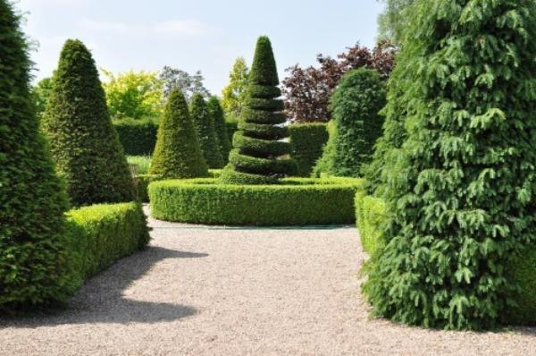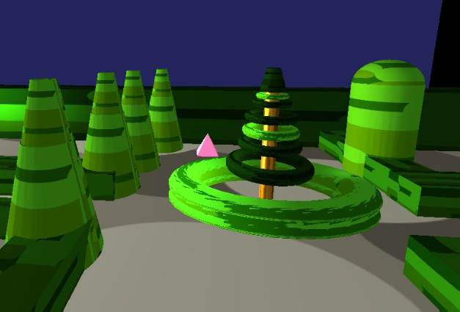
This originally meant that I would use shapes to blob out sections of the image and then make code representation of those images. To do this I used a triangle at position (1f,1f, 1f) to navigate the placement of objects in the scene hints why the triangle is pink as it stands out against the greens, grays and blues of the background. Regarding used shapes the original design for the shapes used in the scene focus on the use of tapered cylinders one for each tree however this proved difficult as a single tapped cylinder face to accurately capture the dimensions of the trees. To solve this I split each tree between two tapered cylinders. This prevents the object from looking stretched, in addition, by accident it also makes the hand made textures blend better.
The camera is controlled through WASD keys and can swap between orthographic and 3d display. To go up and down you can use Q and E. The reason I chose this angle for the photo was to capture the triangle used for positioning. While not done here, it can easily convert the WASD key movement to a joystick movement by swapping out getKeyboardEvents and getCursorPosition with the getJoystickAxis then wedding the extra tools to make the scene come together.
Regarding custom functions the mouse movement and keyboard input functions are likely to become my most reused. These functions represent crucial elements of software design which is user input and can be used for programs in the art, gaming, and engineering fields outside just movement. Furthermore, the design for the camera movement can be used to develop cutscenes in the gaming field if I wish to take that route. On the topic of specific design elements I have my design decisions below and why.
- Shapes and positions
  - The majority of the shapes were chosen because I believe they would add a level of uniqueness to the coding experience. The hedges are longer cubes and the trees are tapered cylinders except for the far right tree that is a cylinder and a half sphere. The centre tree is made out of torus’ with a cylinder as a trunk and a tapered cylinder representing the top. This gave the image a lot of dynamic functionality which made the code fun to make
- Camera Placement and movement
  - The placement of the camera was predetermined by the project. However, I chose the speed at which it moved based on what felt normal for me during the project. This resulted in the camera feeling like it moved at a leisurely pace which fits the scene.
- Textures
  - The textures were made by hand as I wanted to test the method shown in the SNHU texture PDF to make dynamic textures. The reason I chose different colours for the greenery was to break up the images, so the scene did not feel flat.
- Lighting
  - The lighting was the most difficult part as originally I wanted to add a light above the scene to add the necessary light to the top of the hedges. However, no matter how much I increased the diffuse and lowered the ambient, the sides of the hedges would be lit up removing the shadows on the trees. Essentially for the purpose of making the scene as accurate as possible I had to bite the bullet when it came to lighting.

